GENERAL INFORMATION

- ORGANIZER: FECPC

- DATES : 8th (arrival day) to 11th of June – Finals and departure

- CITY: Barcelona

SPORT PROGRAMME FOR 4 or 6 TEAMS:

- Thursday, 8th June Arrivals

  - Friday, 9th June First Competition day

  - Saturday, 10th June

- Sunday, 11th June Finals and departure
(Around 15:00 end of the competition and Prize Giving Ceremony)

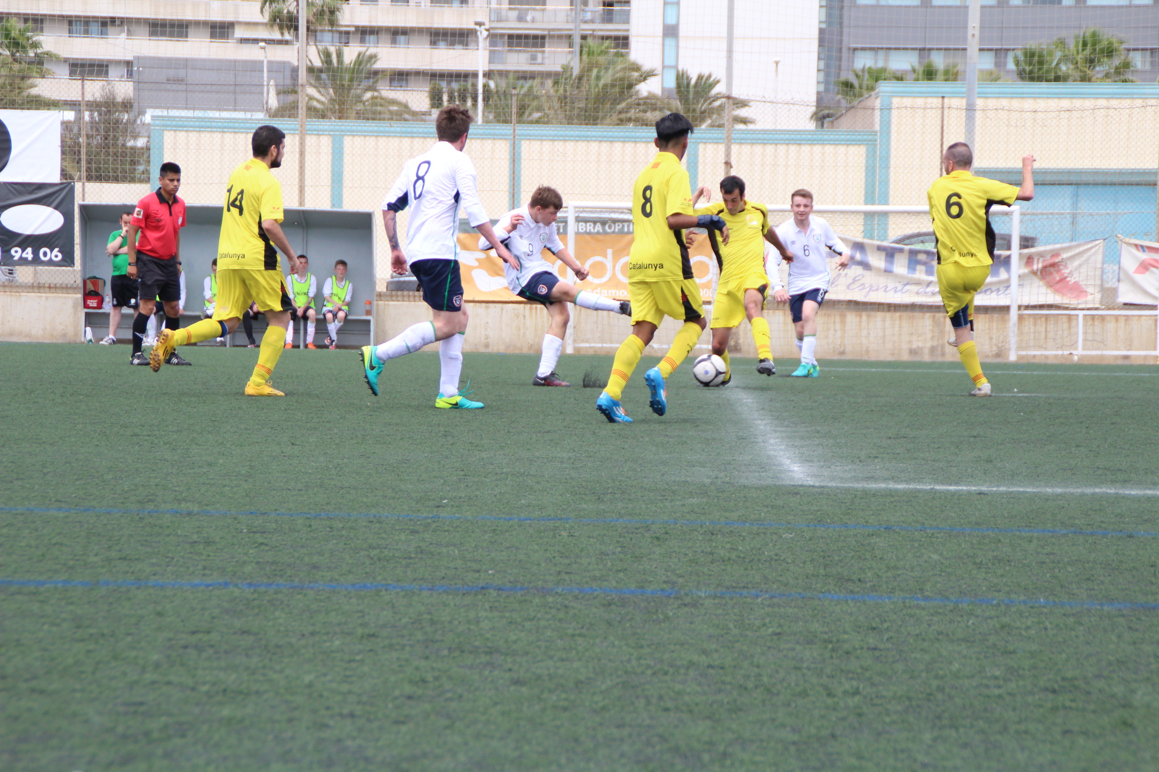

ENTRIES & ACCOMMODATION INFORMATION

Inscriptions include:

- Full board accommodation from Thursday 8th (dinner) to Sunday 11th (lunch)

- Transport from Barcelona airport.

- Entry fee per athletes & staff: 150€ per person (maximum 16 people)

- In case your team is over 16 people, the extra fee will be of €200

- Every team will dispose of two rooms for 8 players (to be used as necessary) and two double rooms.

- Extra meal: 12€ per person
- Extra days: Half pension: 75€/per person in rooms for 8 persons
Full pension: 90€/ per person in rooms for 8 persons
Just Breakfast: 60€/ per person in rooms for 8 persons

Single or double rooms:
Just Bed&Breakfast: 100€/per person and day
Half pension: 115€/per person and day
Full pension: 130€/per person and day

Teams will be accommodated at Barcelona Sailing Hostel which counts with very good facilities including laundry service, gym and spinning room as well as meeting rooms.

Barcelona Sailing offers too other activities during your rest time like diving, windsurf or kite-surf.

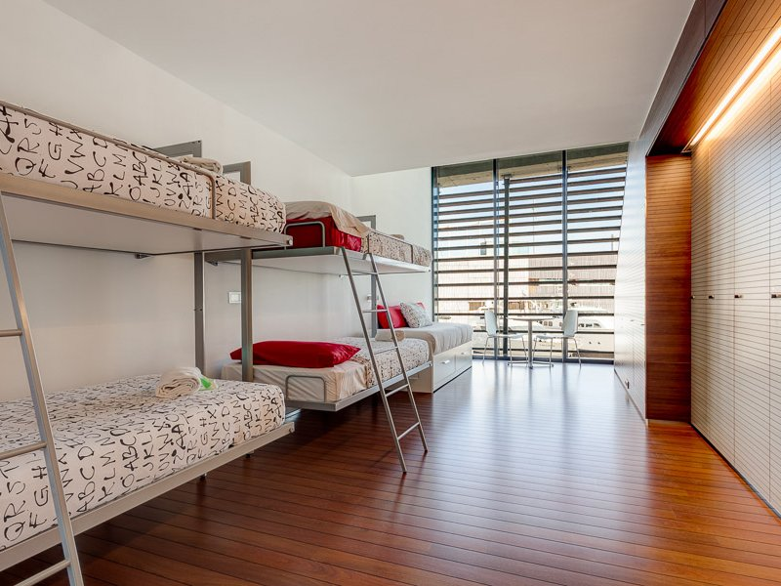
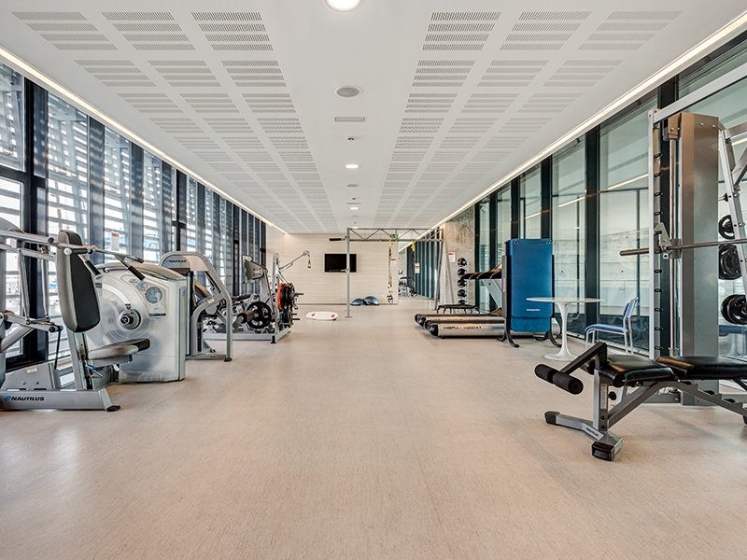

Rooms Gym
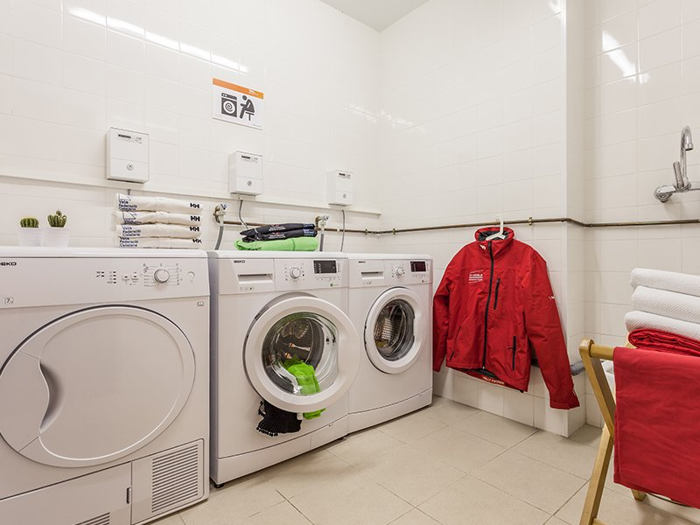
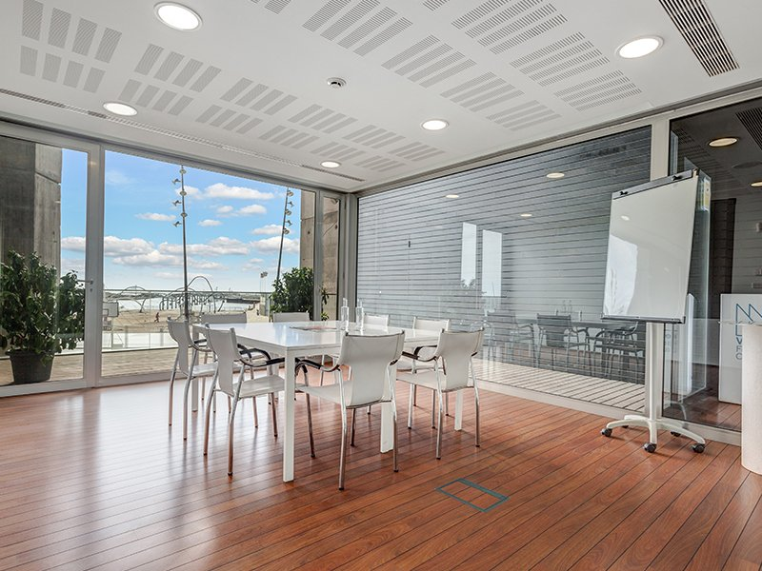

Laundry service Meeting room

TRANSPORT:
The organization will cover transport from the airport of Barcelona el Prat to the hotel.

- 1st ENTRY: DEADLINE: 31 November, 2016

Entry fee: 500€. This quantity will be automatically discounted to your delegation from the total amount.

TECHNICAL INFORMATION

- COMPETITION
- The competition will be led by the rules of the IFCPF.
- Competition is open to 4-6 teams

- COMPETITION REGULATIONS

  - Type of players accepted
All participants taking part in any of the events that the FECPC organizes must be over 15 years old, suffer from brain palsy and have a functional classification attending to the IFCPF regulations. The 7-a-side football only includes players with C5, C6, C7 ad C8 classifications.

  - The match
FIFA regulations are applied to this competition, along with the exceptions established by the FECPC.
- The field area will not be bigger than 75m x 55m neither smaller than 70m x 50m
- The goal will be 5m x 2m

  - The ball
As FIFA’s regulations require.

  - Number of players
    - Each team will have a maximum of 7 players playing at a time (including the goalkeeper). The match won’t take place if any of the teams has less than 4 players.
    - Only 5 substitutions are allowed during the whole match, taking into account that a player that has been substituted cannot go on the field again.
    - Each team must play with at least one C5 or C6 on the field. Otherwise, the team will just play with 6 players.
    - Each team must play with no more than one C8 player on the field.

  - The referee
As FIFA’s regulations require.

  - Length of the match
The match will consist of two 30 minute halves and a 10 minute break in between. Added time will be as FIFA’s regulations require.

  - Start and restart of the match
As FIFA’s regulations require, but players will be standing at 7m from the ball.

  - Fault kick
As FIFA’s regulations require, but all opposing players must be standing at least at 7m from the ball.

  - Penalty kick off
As FIFA’s regulations require.

  - Throw-in
As FIFA’s regulations require, but it is allowed to roll the ball instead of throwing it.

  - Goal kick
As FIFA’s regulations require.

  - Corner kick
As FIFA’s regulations require, but the opposite must be standing at least at 7m from the player who kick the ball.

  - Competition Team
A list with the team members must be done at the start of the competition. Only players on this list will be able to take part in the competition. Before each match, a list will be given to the referee.
All players and technical staff must have their personal technical card.

  - Competition format and scoring
In case of not being able to go ahead with the whole confrontation table, a development and scoring system will be established before the beginning of the competition.
- The scoring system will be as follows:
- Win match = 3 points
- Draw = 1 point
- Lost match = 0 points

  - The ranking system will be as follows:

    - First: the team with more points
    - Then: Goal difference
    - And then: Biggest number of goals
    - If two or more teams are draw in the above criteria, the following will determinate the ranking:
    - The team with more points (in the matches where these draw teams are involved)
    - Goal difference (in the matches where these draw teams are involved)
    - Biggest number of goals (in the matches where these draw teams are involved)
    - A maximum of 10 goals will be counted in these criteria.
    - In case of draw again, penalties will be thrown.

  - Discipline
- If a player gets two yellow cards or one red card during the match, this will have to abandon the field, his team will just have 6 players on it for the rest of the match and he will be discarded for the next match.
- Players, who get two red cards during the competition, will be discarded for the rest of it.
- Cards will pile up all along the competition.
- The Organization Committee is allowed to suspend players in serious bad manners cases.

  - Appeals jury
The Jury will deal with all complaints which are not considered in the above rules. This jury will consist of a manager of the FECPC, a manager of the Organization Committee and the Referee.

